Inland Chapter
929 Bridge Street
Colusa, CA 95932
www.cesa.net

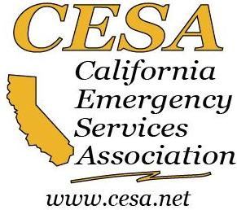

GENERAL MEETING OF THE INLAND CHAPTER
FEBRUARY 23, 2017 1:30PM – 3:30 PM
YOLO COUNTY EOC
120 West Main Street, Suite E
Woodland, CA 95695

AGENDA

1. Call to Order

2. Roll call of Officers. Round Table Introductions

3. Additions/Changes to Agenda

4. Approval of Minutes (10/5/16 State Conference in San Diego)

5. Treasurer’s Report
a. Budget

6. Membership Report
a. Membership Drive Ideas

7. Policies and Procedures
a. Status of updates

8. Secretary’s Report
a. Records

9. 2017 State Conference, Tenaya Lodge Yosemite
a. Save the Date, Oct. 9-12, 2017
b. Elections
c. Awards

10. Committee Updates
a. Confirm Committee Members

12. State Board Report

11. Communications Received

12. Set next meeting

13. Adjourn

President
Janice Bell
Colusa County
Sheriff’s Office, Office of Emergency Services
jbell@colusasheriff.com
530-458-0218

Vice President
Dana M. Carey
Yolo County Office of Emergency Services
Dana.Carey@yolocounty.org
530-406-4933

Treasurer
Scott Bryan
Yuba County
Office of Emergency Services
sbryan@co.yuba.ca.us
530-749-7521

Secretary
Vacant

Immediate Past President
President
Jennifer Broussard
Woodland Healthcare
Jennifer.Broussard@DignityHealth.org
530-669-5312

Member at Large
Jerry Quinn
Gerald J. Quinn & Associates
jerryquinn@gjquinnassociates.com
916-351-1831
Inland Chapter

Alpine
Amador
Butte
Calaveras
Colusa
El Dorado
Fresno
Glenn
Kern
Kings
Lassen
Madera
Mariposa
Merced
Modoc
Nevada
Placer
Plumas
Sacramento
San Joaquin
Shasta
Sierra
Siskiyou
Stanislaus
Sutter
Tehama
Trinity
Tulare
Tuolumne
Yolo
Yuba

